Quadruped rigging with Quick rig in Maya software

Yangyang He, Chul Young Choi

Graduate School of Dongseo University, Dept of Visual Contents,Dongseo University
E-mail：89916508a@gmail.com, freechoi@dongseo.ac.kr

Abstract

Rigging is the main role for connecting two process, modeling and animation. Recently various auto rigging middle-wares come out to help rigging for animation production. However, the major functions of auto rig software focus on biped creatures and it does not have the consistency of working process for quadruped creature. On this paper, we’ll examine the issues of auto rig for quadruped creatures which are generated for general usage and also the issue of production using humanIK control GUI.

Keywords-Rig; Quadruoed creature; Quick rig; Humanik

I. Introduction

3D CG Technology extensively applied to film VFX and animation in digital era. Rigging is the essential work process in 3D animation and VFX and it is the bridge between modeling and animation work. Often rigging on Maya is considered major two process : General rigging and auto rigging. General rigging means that riggers check the model, manually put joint structure and make constrain and fk-ik functions etc. Auto rigging is the tool autodesk maya provides to user. It uses human IK system and automatically generates rigs for digital model without classic rigging process. However, the humanIk is only made for biped creatures not quadruped creature and it has some technical issue if it’s applied to quadruped creatures.
We examine the technical issue of maya auto rig for quadruped creatures and present the solution of generating quadruped creatures in quick rig and humanIK in maya.

II. Auto rig for quadruped creature
A. Humanik

HumanIK tools in maya provide 3 major environment for game animation team[1]

① More realistic real-time animation.
② Reduce the repeating working time of real time animation, nonlinear motion apply and re-targeting.
③ Efficient animation without technical trouble shooting time.

Autodesk® HumanIK® (HIK) animation middleware is a full-body inverse kinematics (IK) solver and retargeter. HumanIK tools in Maya provide a complete character keyframing environment with full body and body part keying and manipulation modes, auxiliary effectors and pivots, and pinning. HumanIK also provides a retargeting engine that lets you easily retarget animation between characters of differing size, proportions and skeletal hierarchy.

B. Issues on HumanIK for quadruped creature

For apply humanIk on quadruped creature, we need to change the neutral bind pose of quadruped creature to the pose of biped creatures in advance. The biped pose for quadruped one is not looking appropriately however we should follow this to provide right structure and measurement to HumanIk system. The requirement of neutral pose should apply to all quadruped creatures no matter how it’s built or what it is.

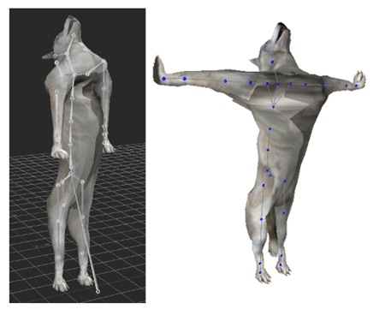
• Character should face forward z plus axis.
• Spines should align to vertical Y axis.
• Head should line up with hip within 5 degree vertical. Neck can has offset in vertical if it’s necessary.
• Rear legs must line up with Vertical Y axis. This is extended from hip to feet. Rear hoof or toes should face forward(Z plus Axis). For the best result of getting ground contact point, rear hoof or feet should be horizontal to ground.

Fig. 1 HumanIK initial pose[2]

C. Quick rig for quadruped creatures

HumanIk has potential of reducing rigging processing, easy rigging and integration with motion capture data. Since the limitation of humanIk. maya has new quick rig from maya 2017.
The basic build process of the quick rig is similar to humanIk and the beginning process is more automatic. Maya users can move the position of joints as they want. Since this new tool added in Maya, we can easily create quadruped rig with this.

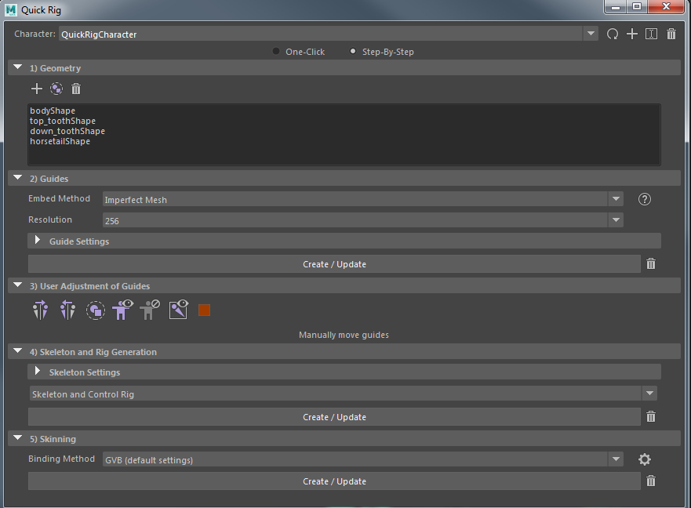

Fig. 2 Quick rig Menu

D. Issues of quick rig for quadruped creatures

Even with quick rig, we can build various structure of creatures comparing to humanIk, still quick rig’s standard structure frame is biped creatures. In consequence of this, quick rig has basic biped limbs as build option : head, neck, spine, leg, arm, hands, foot. Therefore it’s not possible to apply quick rig to quadruped creatures that has four legs without any issues.
Also quick rig generate automatically hands and foot but not fingers and toes. We need to re-adjust shoulder and pelvis that are made for biped creatures. Quadruped creatures like horse and dog, they have developed fingers that are matching to leg of biped creatures.

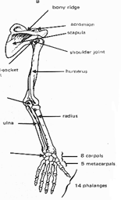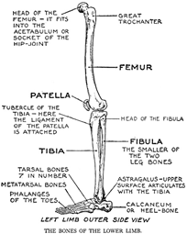
Human’s arm and leg skeleton
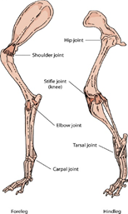  Dog’s front and back leg skeleton | 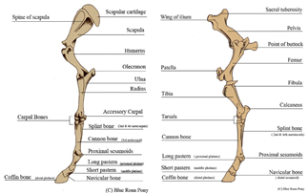  Horse’s front and back leg skeleton

Fig. 3 Anatomy of human, dog and horse’s limbs

E. Solution for issues of quick rig

a. Add user defined joints

New joints should be created in addition to the basic joint that is made from quick rig. see <Fig. 4>. Foreleg of quadruped is matching to forearm of quick rig which generates only <shoulder>, <arm>, <fore arm>. The skeleton of structure of quick rig arm is not sufficient to make rig for quadruped leg and user should create <front mid leg> and <front foot> and put under <fore arm>. As same as the foreleg, quick rig build automatically <up leg>, <lo leg> and <foot>. User should make additional joints like <back mid leg> and <back foot> under <foot> skeleton.

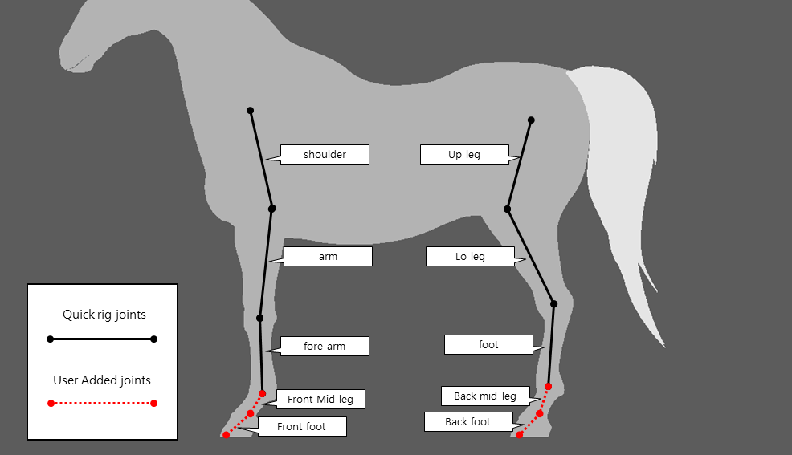

Fig. 4 Quadruped creature structure made by quick rig

b. Adding user defined rigging system

For helping animators, we made user defined controllers that is similar to human feet rig. They are more intuitive to use for animation. The animation movement of legs can do rotation and ik- translation simultaneously. It help animators can make various leg poses without any problem. We added auxiliary handle that works like classic ik handle and it makes realistic leg movement of quadruped creatures easily.

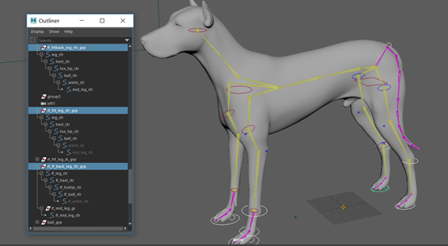

Fig. 5 User defined controllers

User defined joint should be connected to joints under <character – reference> group. We can connect this to quick rig with two method : parenting and parent constraint. We recommend to use parent constraint method because this has more neat hierarchy and easy maintenance. The transform nodes will be animation handles that are connected to effectorAux with point constraint.

III. Advantage of quick rig for quadruped creatures

The classic rigging process needs a plenty of R&D time and efforts. The movement of spine and neck as well as 4 legs are crucial for quadruped animation and without rigging specialist, it’s not easy to build them.[3] Quick rig provide us easy and robust basic rigging system for this. With adding some joints and user define rigging to quick rig, it will help rigging process easy and fast and the rigs are robust for any time of animation. This method shares the advantage of both rigging system : classic 4 legs rigging that has intuitive animation controls and human Ik system that provide realistic movement and fast rigging.

IV. Conclusion

On the animation production, the character rigging is the time-consuming and technology based process. Building quadruped creatures has high difficulty and it needs long production time.[4] Auto rig system developed for overcoming those issues with automated and intuitive working process. As explained above sentences about the benefits from humanIK system, the expanded role of digital creatures on feature film and animation needs high ends data re-targeting technology and general rigs for applying re-targeting. Autodesk Maya only provide biped creatures for auto rigging system to end users. This paper researches and explains the method how maya users can apply maya auto-rig to quadruped creatures as main issue. This method will reduce production time on rigging quadruped creatures and animation process with intuitive humanIK GUI. On the following research, we’ll practically apply this method to animation production and compare the mechanical movement of quadruped creatures and biped creatures.

References

[1] Gaurav Bharaj, Thorsten Thormählen, Hans-Peter Seidel, Christian Theobalt “Automatically Rigging Multi-component Characters”
[2] Autodesk Maya Manual, “Human IK”, http://help.autodesk.com/view/HUMANIK/2016/CHS/?guid=__files_GUID_35B7996F_71E1_420E_A9DF_1DB4C3DFCFBC_htm
[3] Liu Huiyuan, Zhu Enyan, “Art of Rigging-Maya Advanced rigging technology”, Posts&Telecom Press
[4] Tina O’Hailey, “Rig it Right!-Maya Animation Rigging Concenpts”, Focal Press
[5] http://area.autodesk.com/blogs/stevenr
[6]http://wenku.baidu.com/view/579744f8c8d376e_eaeaa31a2.ht ml
[7] https://www.youtube.com/watch?v=blLBRmNA3zI
[8] Liao Yong, “Secret of Maya Character Rigging”, Tsinhua university press

